**UMLx System Tutorial:**

1. **Source code structure**

data/: stores the UML diagrams collected from the selected projects, there might be more to be added in the future. The files with surfix .xml are exported from Enterprise Architect for the UML diagrams.

db_backup/: the backup of current database, which is based on MongoDB.

documents/: the documents about the system configuration, tutorials of system structure, or functionality explanations.

evaluators/: this folder contains high level analysis for the extracted information from UML diagrams. For example, to use the number of transactions to calculate Use Case Point. Each of the JS files is an Evaluator, which is used as a plugin to register in UMLEvaluator.js.

model_drawers/: include the methods to visualize the extracted models, for example, user-system interaction model, transaction, etc.

model_platforms/: this folder contains the low level operations to parse a specific format of the exported files for UML models. For example, ea/XMI2.1Parser.js parses the information from the xml files exported from Enterprise Architect.

node_modules/: includes the installed nodejs plugins. We usually don’t touch the folder.

public/: stores the uploaded data (the exported UML files) from the web portal, also the outputs from different analysis.

Rscript/: includes the R scripts for statistical analysis for the extracted information from UML models.

Temp/: store temporary files.

Views/: include templates for web pages, written with the Jade plugin of Nodejs.

UMLEstimator.js: used to receive commands for model calibration.

UMLEvaluator.js: the abstraction for the evaluators. It currently registers the evaluators under the evaluator/ folder, for example, COCOMOCalculator.js, UMLModelEvaluator.js, and UseCaseCalculator.js.

UMLFileManager.js: the UML model file manager module, which manages uploaded model files.

UMLModelExtractor.js: start the procedure for extracting user-system interaction model from UML diagrams.

UMLModelInfoManagerMongoDB.js: includes the database management functions, for example, querying model or diagram information.

UMLxServices.js: includes the Restful APIs to request the analytical data, including the Url access entries for the backend functionality.

1. **Programming Language:**

Nodejs, Javascript, HTML, CSS, R scripts

1. **Dependencies:**

NodeJs (with modules: multer, admzip, express,path,jade)

MongoDB

Graphviz 3.2.5

1. **Platform:**

Windows or Mac OS or Linux

1. Clone from github:
   1. “git clone <https://github.com/flyqk/UMLx.git>”
   2. Create two folders under the project root folder:
      1. “./public/uploads”
      2. “./public/output”
2. **Server Setup:**
3. install mongoDB. (<https://docs.mongodb.com/manual/installation/>)
4. Start mongodb:
   1. Navigate to the database folder of MongoDB. The default folder for MongoDB installation is : ~/Documents/db. Or you can also create the folder, for example, D:\data\db
   2. started MongoDB with “mongod –-dbpath “d:\data\db”
5. Install nodejs. (https://nodejs.org/en/download/)
6. Install dependencies using `npm install` from project dir <Project Dir>
   1. Using command to start mongoDB : mongod –-dbpath .
7. Start web service:
   1. Navigate to your project root folder.
   2. Using command to start UMLxServices: node ./UMLxServices.js
8. Access: (<http://127.0.0.1:8081/>) to load the home page.
9. **Data Setup (This is only for database backup and restore. You don’t need to do these steps at your initial setup. You only need to use this when you want to save current dabase or retore some others):**
   1. mongodump –-out /data/backup.
   2. mongorestore –-drop –-db db_name <project dir>/db_backup/db_folder_name
10. **Tools Setup:**
11. Install R(3.5.1) into directory: C:/Program Files/R/R-3.5.1 (or another folder)
    1. Put bin folder, for example, “C:/Program Files/R/R-3.5.1/bin/Rscript (or the path you specified)” into path environment variable of OS. Make sure the “Rscript” command works when you type it in a console/command line.

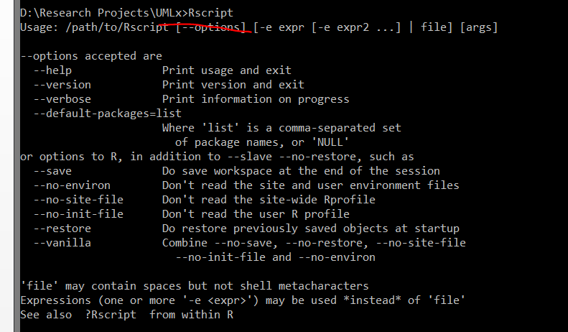

* + 1. Configure R libraries path in ./config.js
       1. Find your R libraries path:

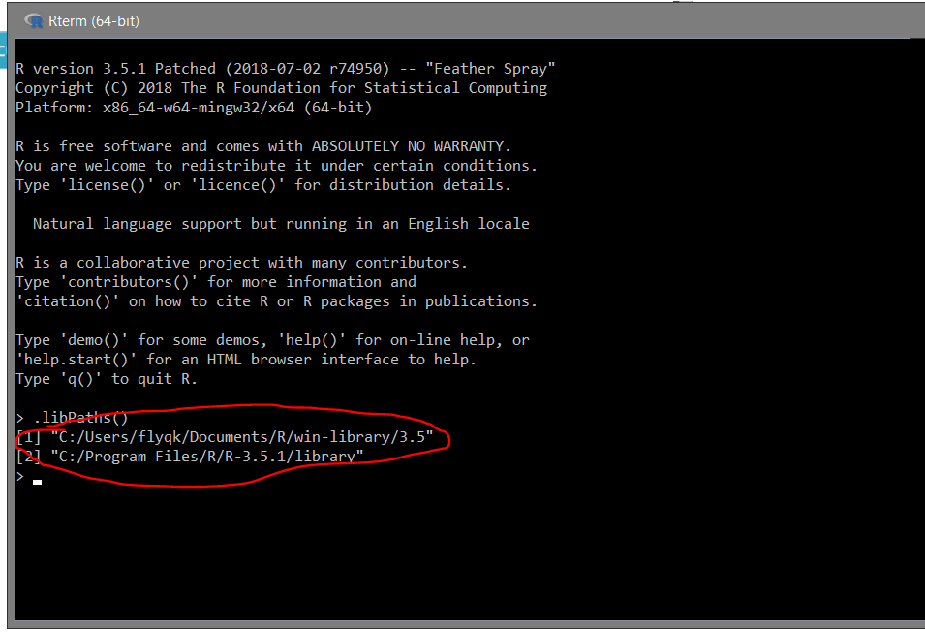

* + - 1. Copy the paths into config.js

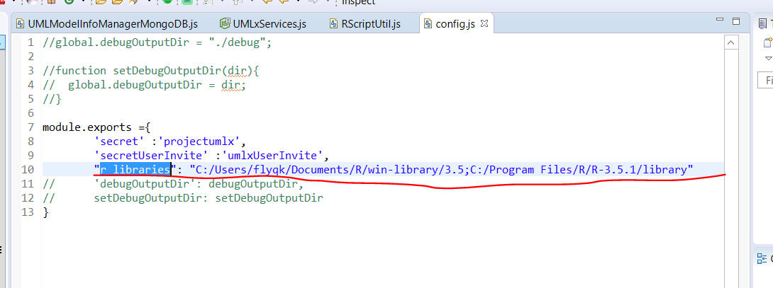

* 1. Intall R libraries:
     1. ggplot2
     2. jsonlite

1. Install Graphviz
   1. Test if “dot” command works in command line.

*You can download the tools from here:

https://drive.google.com/drive/folders/1bD77wI0-nT-j5qUkLGuM6S5DgmtG1Jb0?usp=sharing

Notes: sometimes you may mess up the database for some reason. You can delete the mongodb and restore the backup database. This tutorial is just the skeleton of the process of setting up the project. There might be some variations for different operation systems and environments, or some of the instructions may not be very accurate. In those cases, you may need to do some researches for those steps.

Working in progress section:

1. The environment variables to set.

export ANDROID_SDK=/mnt/h/ResearchSpace/Android_Workspace/Android_SDK

export GatorRoot=/mnt/h/ResearchSpace/ResearchProjects/UMLx/facility-tools/GATOR_Tool/gator-3.5